**Last Week’s Totals**

Total Missions Faith Promise Monthly Commitment: $ 3,095.00

Missions Faith Promise Received in November $1,021.00

General Fund Offering Received 11/24/19 $ n/a

Parking Lot Fund $ 482.00

Missionary Christmas $ n/a

**_________Announcements________**

Mark your calendars….

The VBC kids have been working hard preparing for the Children’s Christmas Program that will be held on Sunday, December 8th at 6PM.

There will be a cookie fellowship following the program. Please bring cookies to share!

**Sunday School - 9:45 AM**

**Nursery**………………..……….…..available for newborns up to 2yrs old

### **Children’s Opening** ……………. ages 2-Sixth Grade. They will be meeting in Christman Hall. Age Appropriate Classes following opening

### **Jr. High Grades 7& 8**…………..….3rd room on the Left in the CAC

**High School Grades 9-12**……………..…………………....Basement

**Adult Sunday School Class-**

**\* 21 things God Never Said”** in Auditorium

**\* Family Life Today Parenting Series**- CAC

**Morning Worship Service- 11 AM**

**Special Music:** The VBC Choir

**Toddlers Church (ages 2-5)**

(must not have started kindergarten)

In Christman Hall for entire worship service.

**Junior Church-** (for grades 5 yrs-4th grade)

Children will be released right before the message

**Children’s Activity Bulletins are available on the back**

**Message:** Pastor Joe Benedict

Christmas is a time of Emphasis

What should we capitalize on this Christmas?

A Time of Giving

**No Evening Service**

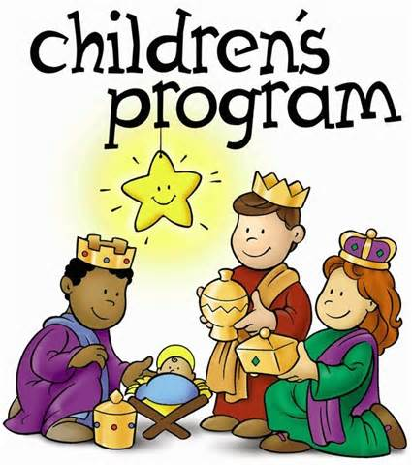

**This Week______________________________________**

**Sunday**

* No Choir Practice
* No WOL Meeting
* No Evening Service

**Wednesday**

* Prayer Meeting 6:30 PM
* AWANA 6:30 – 8:00 PM

**Thursday**

* Grief Share 6:30 – 8:30 PM

***** Next Sunday night- Children’s Christmas program at 6PM

Sunday School AM Service PM Service

|  |  |  |
| --- | --- | --- |
| 12/01  Jody Moore  Sara Martin | Sue Raffler  Mary DeBord  Caleb Farlee | No evening Service |
| 12/08  Jody Moore  Sara Martin | Rebekah Householder  Denise Forell  Kaycee Schrader | Tiffany Blakely |

** Toddlers Church-ages 2-5 (must not have started kindergarten)**

**COMING EVENTS**

**December 8-** Children’s Christmas Program 6:00 PM

**December 14**- Ladies Christmas Tea 10 AM

**December 22**- Cantata during the 11AM Service



We are looking for anyone who plays a band instrument and would like to join us in the Holiday Band for the month of December as we play Christmas music during the Sunday morning worship service. Please see Judy DeGroot if you want to join the band or for practice time.

**O. C. C. SHOEBOX!!!**

**We made a total of 215 boxes this year!!!**

**The largest collection in VBC history!**

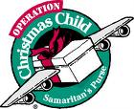

Missionary Christmas

This morning We will be taking up a special 2nd offering during the morning service for the missionary Christmas. Please consider giving towards this to make our missionaries know how much we care about them and the dedication to the mission field they serve in.

Grief Recovery Support Group meet weekly on Thursday nights Thru December 19 from 6:30-8:30 PM.  Grief can be lonesome.  Professional support on DVD's will be facilitated to provide comfort in a confidential setting.  We are never prepared for loss and we are here to help our church family and community.   Questions?  Just come or call Ardy Robotham 517-852-4001.

Ladies, you are invited to a Christmas Tea on Saturday, December 14 at 10am.

Bring a brunch dish to pass and a teacup.



We will be having an ornament exchange. It can be new or old. Make sure to have it wrapped. Hope to see you there. We always have a good time, If you have any questions, please contact Pam White 269.331.9183 or 517.852.9490

**This Weeks Verse Challenge- Verse # 14**

**John 10:28 ESV**

I give them eternal life, and they will never perish,

and no one will snatch them out of my hand.

Now available on the foyer table-

“Our Daily Bread”

A **FREE** Daily Devotional

for December, January and February.

Pick up your copy today!



Children will be in Christman Hall throughout the entire 11 am worship service. Parents please pick up your children immediately following the service.



**Schedule**

**ee**





We are raising money to fix the parking lot. You may give towards this by designating funds for the Parking Lot using an offering envelope and writing “Parking Lot” in the “Other” area listed at the bottom.



Hello Ladies it’s Tea time! Our first tea this season will be Oct.13, at 10:00 a.m. The title is “Incredible Edibles”. Bring a snack with something made from the garden. Can be vegetable, fruit, herbs, or flowers. The tea will be hot and ready for you. Looking forward to seeing you this year. Pam P.S. I have plenty of cups if you forget yours.

Hello Ladies it’s Tea time! Our first tea this season will be Oct.13, at 10:00 a.m. The title is “Incredible Edibles”. Bring a snack with something made from the garden. Can be vegetable, fruit, herbs, or flowers. The tea will be hot and ready for you. Looking forward to seeing you this year. Pam P.S. I have plenty of cups if you forget yours.



VBC has enjoyed these retreats since 1994. We leave around 4pm Friday and return 48 hours later. The carpool there is just part of the fun. This is a great time to get to know your brothers at VBC. At Camp we are privileged to have Tom Harmon as our speaker for the weekend. Tom will challenge you to grow in your walk with the Lord and will also share the Gospel. Great opportunity for you to invite a friend, relative or neighbor.

Lodging and all meals (Delicious and abundant) included. Cost is $115. Please see Mike Clark for further information. You can register on the camp website, campbarkel.org. Please make sure you select October 12-14 and you select Vermontville Bible as the group you want to be housed with.

**This Weeks Verse Challenge- Verse # 12**

**2 Corinthians 12:9 (NAS)**

And He has said to me, My grace is sufficient for you, for power is perfected in weakness. Most gladly, therefore, I will rather boast about my weaknesses, so that the power of Christ may dwell in me.







Church Cancellation Information

Ladies Bible Study kicks off This Thursday September 14 @ VBC 7pm

Led by Deanna Clark

We will be studying the book of Philippians.

All you need is a bible, notepad and pen